THE CHALLENGES THAT CONFRONT US AND TO WHICH WE MUST RESPOND.
THE VERY SURVIVAL OF THE HUMAN RACE IS AT STAKE

Ewan McGregor

New Zealand is a microcosm of the planet. Our population is expanding, doubling every half century or so. More people need to be fed here, and we need the income from feeding those abroad. We have less land to produce food through urban expansion, expanding commercial forestry and the retirement into ecological forests. At the same time, pressure mounts for food producers to use less artificial fertilizer, irrigation, oil, and chemicals.

We exploit the fruits of the earth to serve our craving for affluence. This includes the combustion of fossil fuels, that have taken hundreds of millions of years to naturally accumulate.

Much of our commercial exotic forestry has been planted for environment protection, often with the help of public funding, but its extraction in many cases is decidedly environmentally damaging.

Overhanging all of this is the darkening cloud of man-induced climate change and resulting weather disruption. Glibly dismissing this as merely a continuation of historic climate change is wearing a bit thin. It is hard not to accept that something serious is happening to the atmospheric and physical health of the planet, and remedial action is daunting. Nevertheless, we owe it to generations yet unborn to work for a sustainable future.

One policy aimed at the sustainable restoration in some form of the global forests is to establish a mechanism to reward qualifying forests with carbon credits. This is not a subsidy, but a quit pro quo for the penalization of those who emit gases that adversely effect climate stability. It is, however, a political arrangement and carries with it electoral uncertainty. But then, free commercial activity is also uncertain.

Here I promote a landuse that offers a wide range of economic reward, environmental standards, and social and rural landscape stability. I have believed in and promoted this landuse for a long time. Now it offers a new benefit to the farmer – carbon credits - It also can be carried out sustainably through selective logging. SILVOPASTORISM WITH POPLARS (OR OTHER APPROPRIATE GENERA)

SILVOPASTORALISM WITH POPLARS –

Recently I attended the Farm
Forester of the Year fielday at Taumata Farm at Te Awa, in Central Hawkes Bay. One feature was the use of poplars judiciously planted over the hillsides for erosion control where they have stabilised the soil and provided shade for stock. Like 90% of the poplars planted with Catchment Board/Regional Council encouragement, those we saw had had little, if any, after-planting management.

Regional Councils, certainly Hawke’s Bay’s, have never been able to break out of the fixation that you plant a poplar pole for the primary objective of conserving the soil. If it flourishes, which it usually does – it’s a most robust genus – then the objective has been satisfied.

Managing poplars is something I have been advocating for over 30 years, both inside and outside the Council Chamber. The effect of this advocacy has hovered somewhere around zero. Inevitably, the result of untendered trees will be massive poplars dying on their feet in the course of time. It’s well on the way to that now from 1960s/70s planting. If you want to see a manifestation of this, go to Frimley Park in Hastings and view the biggest poplar tree in the world, planted circa 1870 – huge and dying on its feet. It is not a pretty thing, and its removal, now planed, will be quite a very costly exercise by the HDC. This for just a single tree on flat land accessible to machinery.

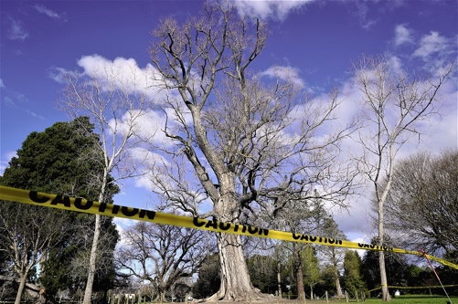
Frimley poplar slowly dying. Sad.

The value of these neglected conservation plantings when they are past their best-before-date will be negative. Yet poplar is globally the most cultivated timber genus on the planet. This seems like a compelling opportunity to realise income while, at the same time, painlessly cleansing the landscape of a looming imposition. It does to me, anyway.

Useless

Getting rid of unwanted trees is a costly business.

Managed poplars with no loss of pasture production – silvopastoralism.

Growing poplars for timber while grazing productive livestock – silvopastoralism – is potentially a most economic use of the land, while at the same time protecting it environmentally seems to tick all the boxes. Well, two of them anyway. But there’s another box which is at least as important, and it is the maintenance of a vibrant social infrastructure of residential ownership and management, now increasingly being threatened by the advance of blanket dedicated forestry – read pines. The socio-economic rural landscape that we have in Hawke’s Bay has been built up over 170 years since the arrival of the first sheep. It can be lost in a season.

But another compelling claim that poplar silvopastoralism makes and which has suddenly emerged, is its potential to yield a harvest of carbon credits. Can this be a means of holding back the tide of pine plantations planted for carbon sequestration, or even radiata timber over lower and stable pastureland. (I hasten to say that I do not wish to
denigrate the planting of radiata for timber. This most remarkable species is the source of nearly all of our lumber, roundwood and pulp & paper requirements, with more earning much needed overseas income. But it best to keep it to the poorer country where it flourished sufficiently to provide a harvest in the remarkably short time of 30 or so years.)

Much great scientific work has been done since the 1950s in developing various clones of poplar for soil conservation planting but it has been focused on disease and pest resistance and adaptability to our pastoral environment. The evidence of the success of this in the field can be seen over our hill country. But, as far as I can see, no consideration, at least of any consequence, has been given to the ability to shed branches, or, at least, not to have prolific sprouting from a wound where a branch has been pruned.

(The two varieties that I have had a long experience with are veronese and kawa, both really fine examples of the genus. The former is a little more robust than the latter, and the most likely to establish in a tough year. But it produces a proliferation of sprouts after a branch is pruned whereas kawa may have the odd small branch that regrows, so it is much more easily managed to a clear stem. I understand that the H B Council is cutting back on the production of kawa poles, evidencing an absence of regard for clear log production.)

Two poplars planted alongside each other on the same day, pruned once. Veronese on he left, kawa on the right.

I have seen many individual examples of poplars that have naturally developed a clear stem and have photographed them and brought these trees to the attention of Council in an endeavour to stimulate interest in this vital characteristic if you are to get timber quality at wide stem spacing. It appears to be entirely unmoved.

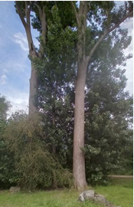
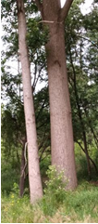

These three images are of unmanaged poplars on the river berm below Waipukurau.

What my Council should do, or better still, in association with other reginal councils, is to establish a trial and demonstration area, or areas, where poplars are planted over land that may or may not be vulnerable to erosion and where the poles are planted at various spacing for the purposes of research. This research to include pasture and livestock production, and this to include both Hort Research (which researches poplars) and AgResearch. A vital part of this is to develop clones more likely to produce a clear stem, essential for the best quality timber.

The objective is to make a leap in poplar cultivation from unmanaged planting for the primary, if not sole, objective of soil conservation, to multi-beneficial purposes of;
- Soil conservation,
- Sustainable timber harvest,
- Carbon accreditation,
- Landscape preservation

- Maintenance of the pastural economy and the family proprietorship and social infrastructure that goes with it.

Ewan McGregor, Waipawa.
Poplar grower since 1968.
Former member of the HBRC.
Churchill Fellow 1994 to study poplar cultivation and utilization in North America and Europe.

See Ewan’s poplar history in photos that follow below…

ADDENDUM IMAGES
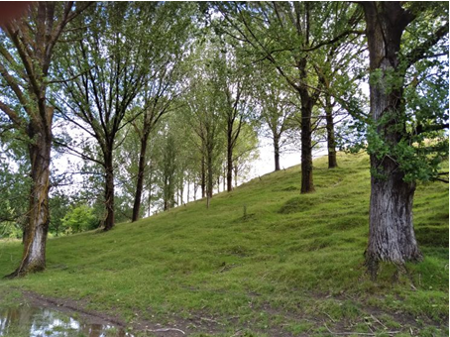

My first planting,1968. Zero silviculture, but moderately good form nevertheless. This was the standard clone of the day, I78 (Italian). Biggest are a metre+ DBH. They have reached their ‘Best Before’ date, but with at least a hundred years of life left. Think about that! No exit strategy. Every one a Frimley poplar in the making. Millions of them. I doubt that there is a better example to illustrate my concerns on the planet – right here in a central Hastings park.

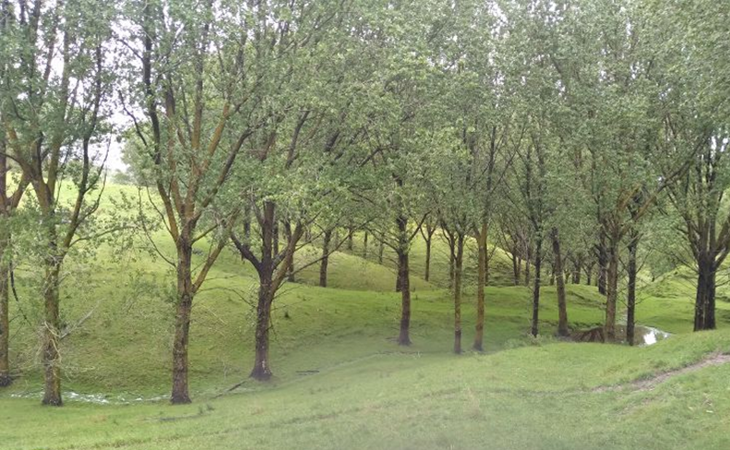

I78, planted 1973 – rust arrived the following autumn and this clone ceased to be supplied, but had good form and vigor. No pruning until 15 years old. Then, in a drought they were pruned, about 10 a day, to feed cattle. Only pruned up as far as could be reached from the ground with a chainsaw. This included large branches that had emerged from the top of the pole, and in about 20% of the cases, secondary leader removed. This made a great difference to form, (see image of pile of logs above), but could have been done with loppers in a few seconds at age two. See image below.

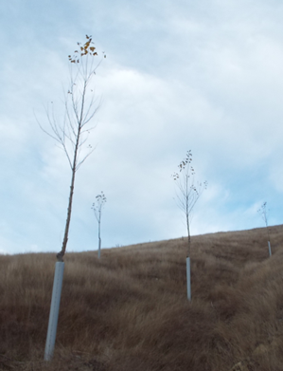

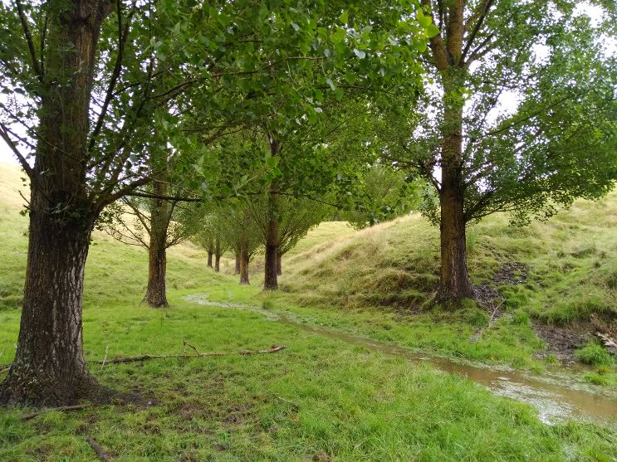

Veronese, planted 1991. Pruned timely, but this species shows vigorous sprouting from the wound which, with the best of intentions, don’t get removed. It’s rather disheartening to prune the same lift twice. Accordingly, this otherwise excellent variety (for soil conservation) is unsuited for silvopastoralism in my view. (As stated above, the HBRC are increasing supplies of this, but reducing kawa. Such is their appreciation of silvopastoralism. I’ve been banging my head against this brick wall for a long time.)

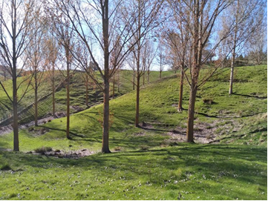

Poplar silvopastoralism as it can, and should be. These trees are 23 years old and within 5 years of millable size, with loss of pasture production; I suspect increased up to that age and beyond. Growth rates of hardwoods respond to soil, so dimensions vary allowing for selective extraction, with replacement, subjecting the forest to carbon credit qualification. Selective extraction over such medium hill country can, surely, be carried out without the traumatic earthworks so common with clear-felling over steep county.

